CREAMY ICE CANDY

FOR SALE!

₱10

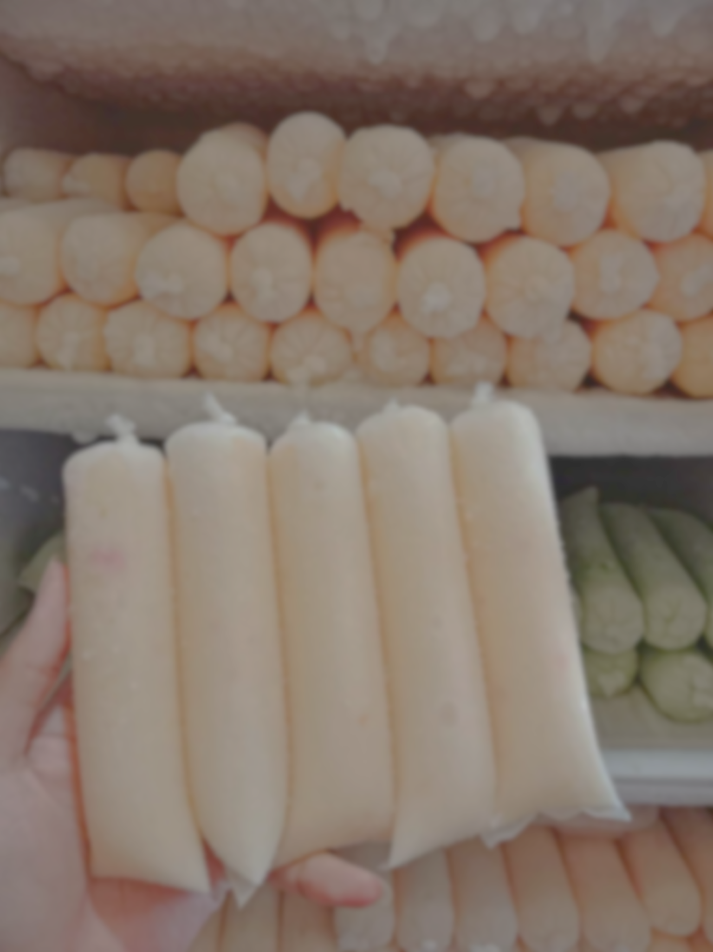

* **Salad**
* **Melon**
* **Mango**
* **Buko Pandan**
* **Chocolate**

**10 PESOS ONLY!**

Creamy

Ice Candy

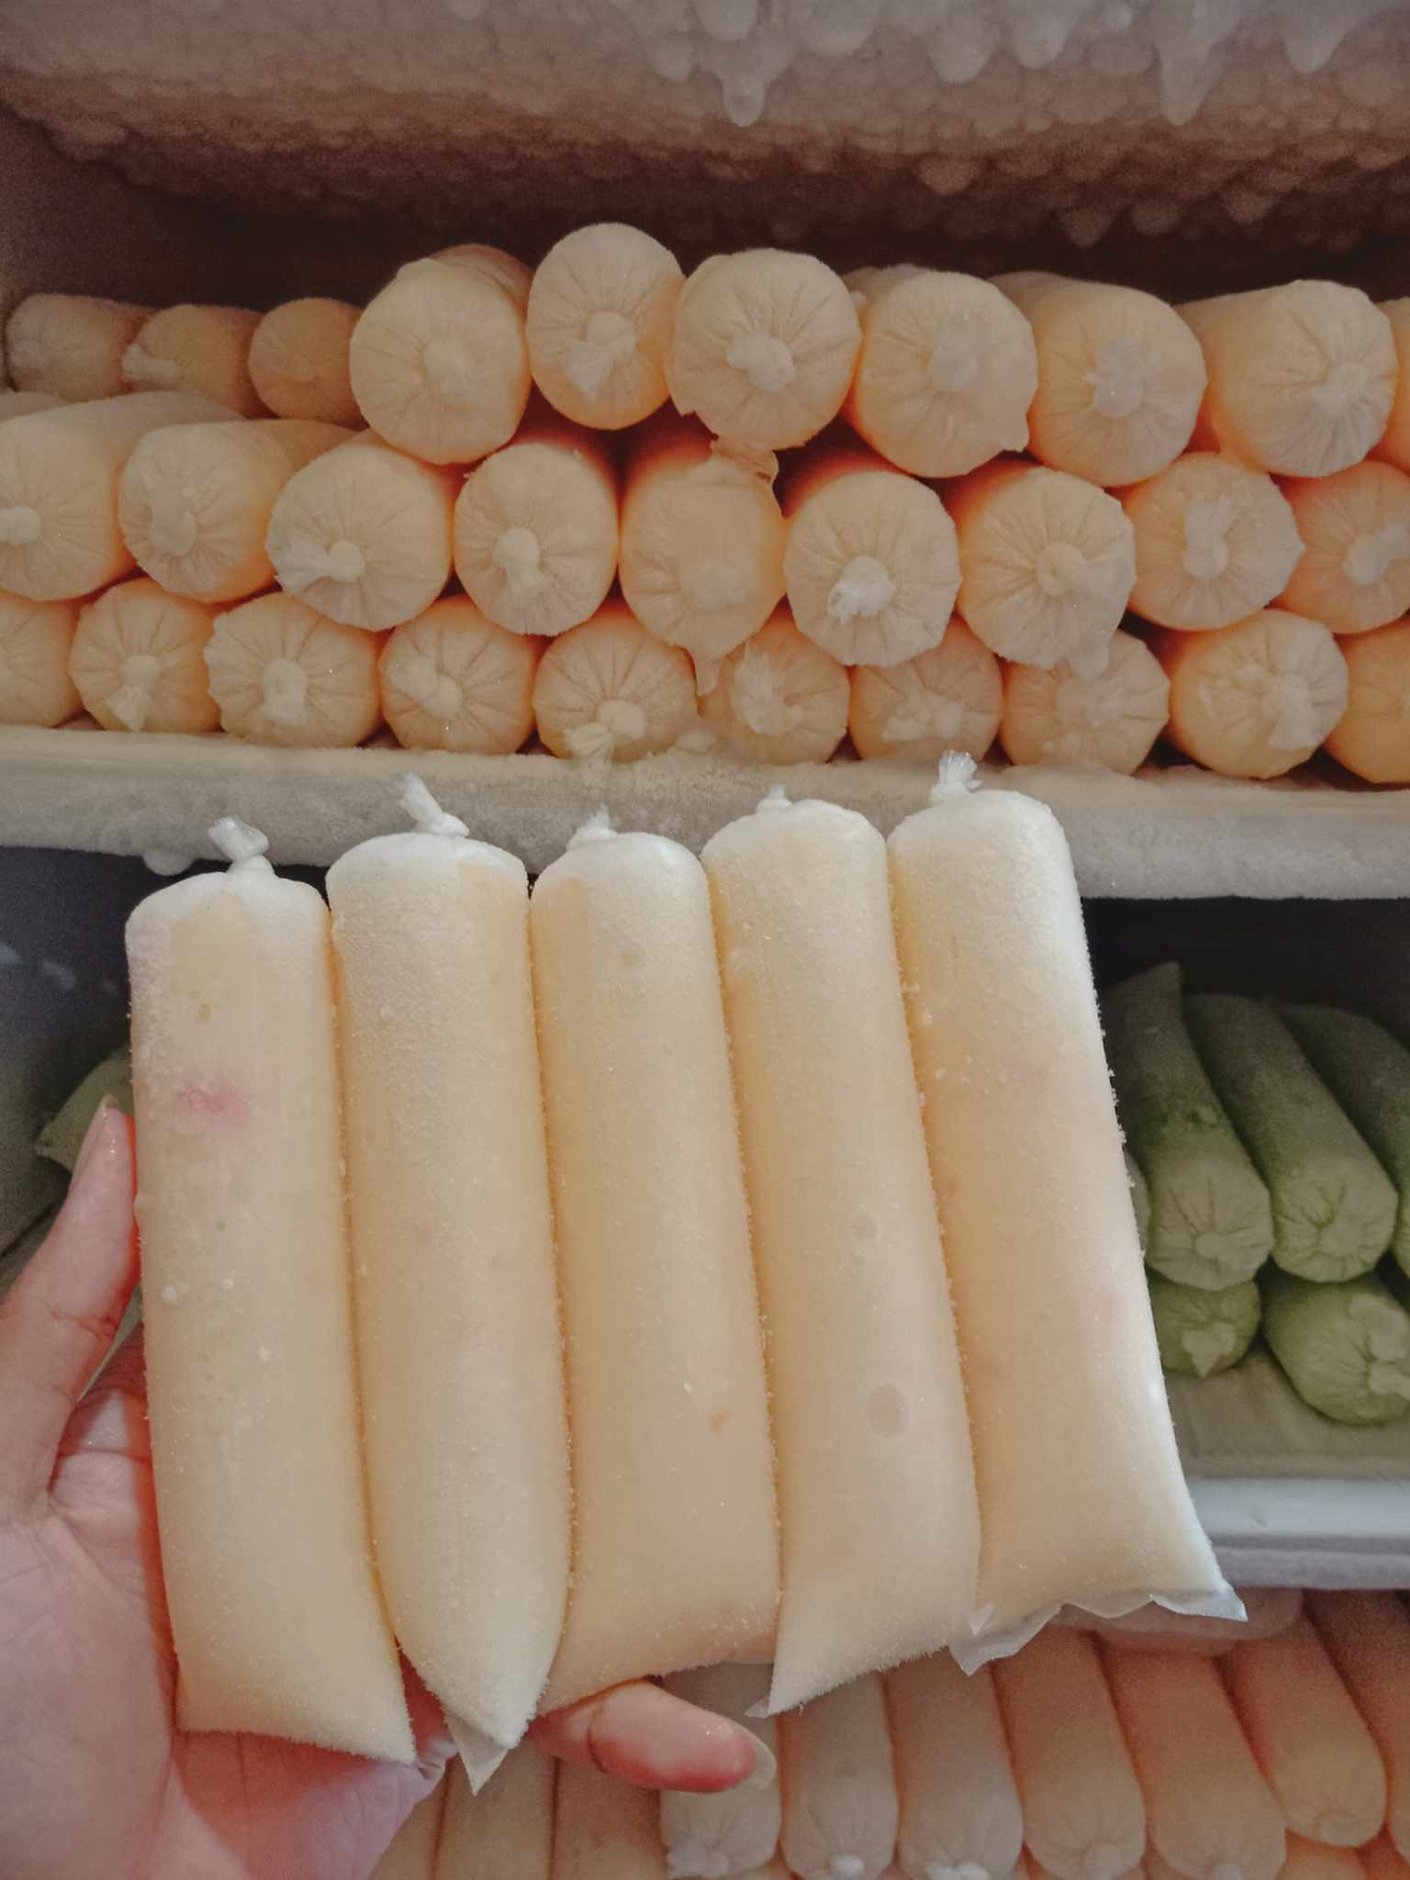

For Sale

Creamy Ice Candy

Flavors:

* Salad
* Melon
* Mango
* Buko Pandan
* Chocolate

₱10